**DevOps Task 5**

**Prometheus Grafana Kubernetes**



Task-5 :-   
  
Integrate Prometheus and Grafana and perform in following way:  
1. Deploy them as pods on top of Kubernetes by creating resources Deployment, ReplicaSet, Pods or Services  
2. And make their data to be remain persistent   
3. And both of them should be exposed to outside world

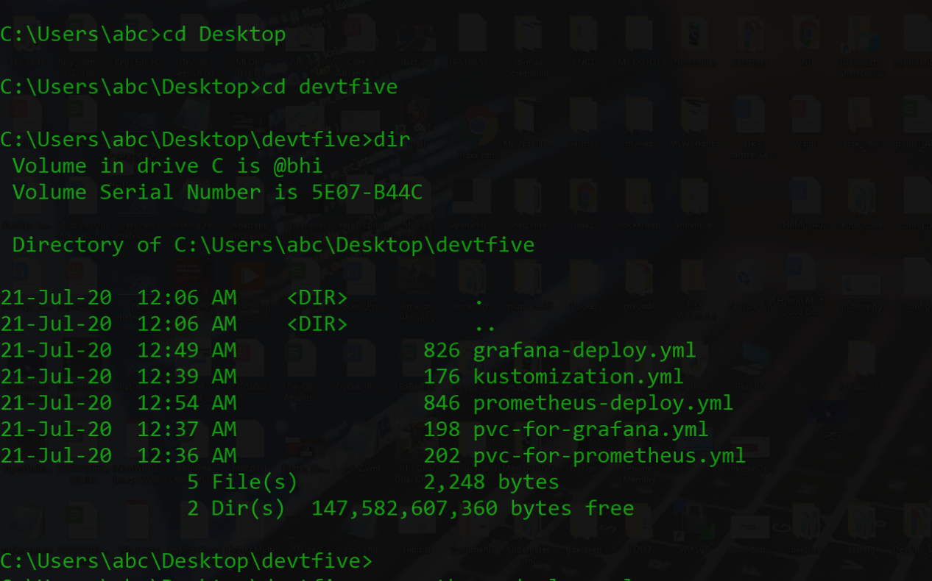

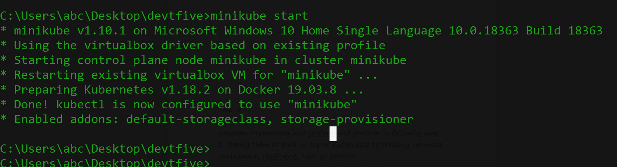

File s That we need during performing this practical

Prometheus pvc:-

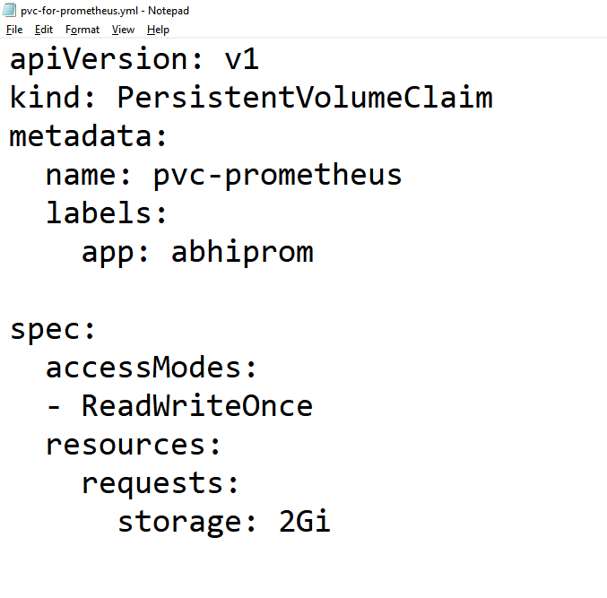

Prometheus deployment :-

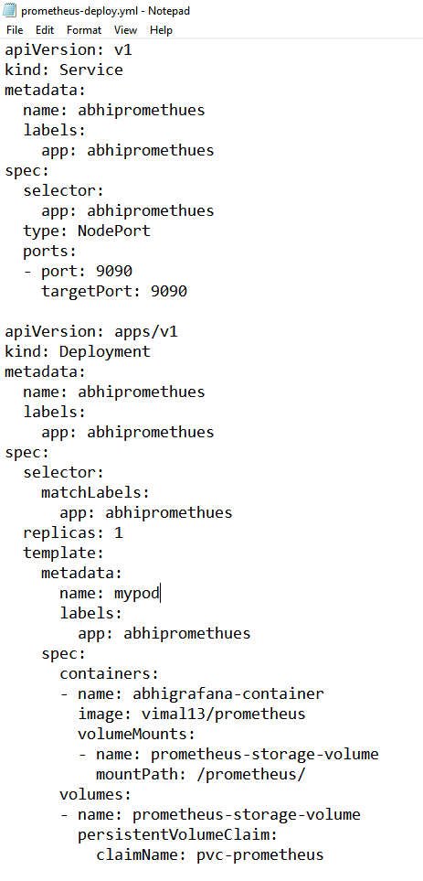

Grafana pvc

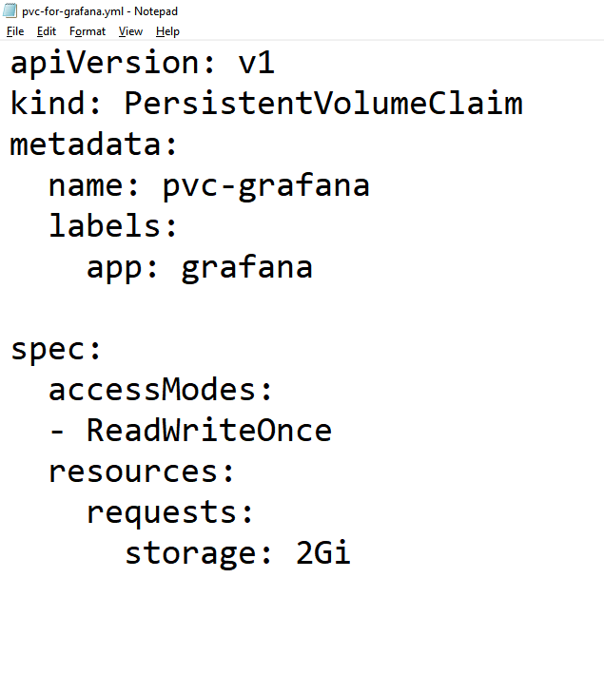

Grafana Deployment

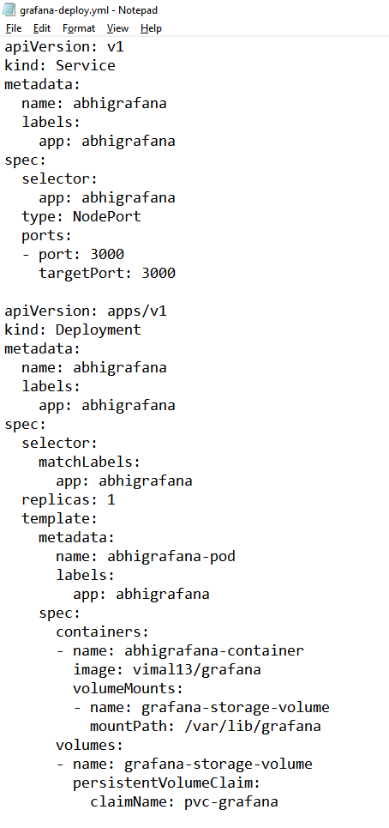

Kustomization File :-

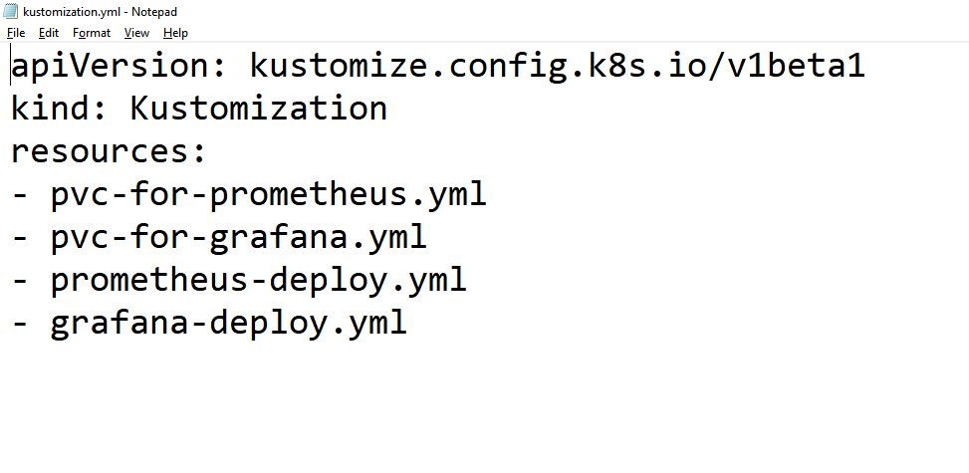

As yOu can See Right Now we Don’t Have any service and pods are running so we are going it from basic and starting and I am going to create the whole environment with one command I.e **kubectl create -k .**

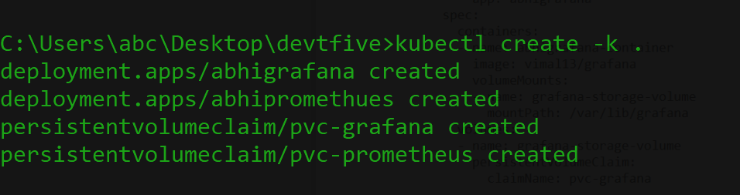

Contaienrs are creating after this they will get ready a pod for us

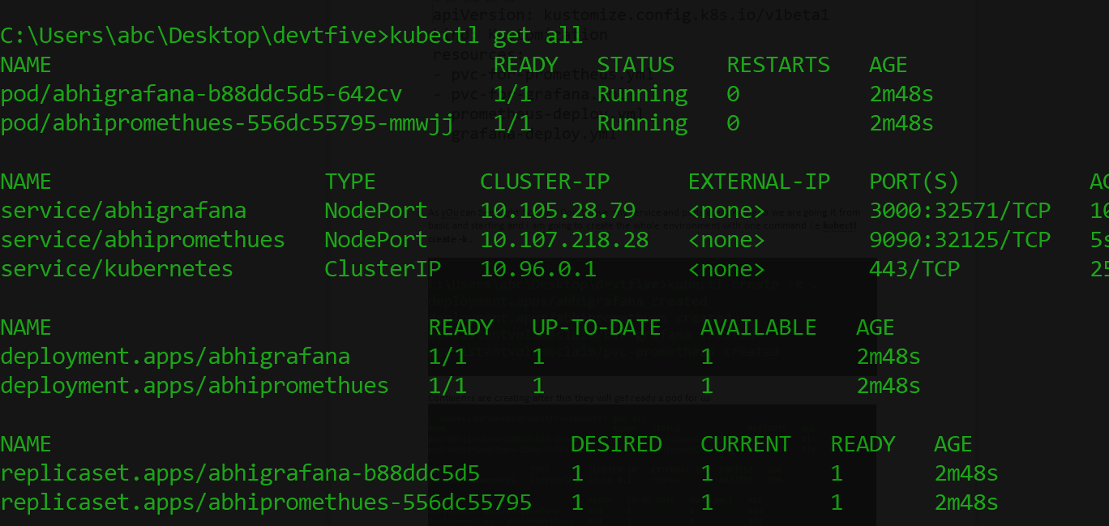

EveryThing is created now we can access prometheus and graafana dashboard On respective ports !!

Prometheus Dashboard :-

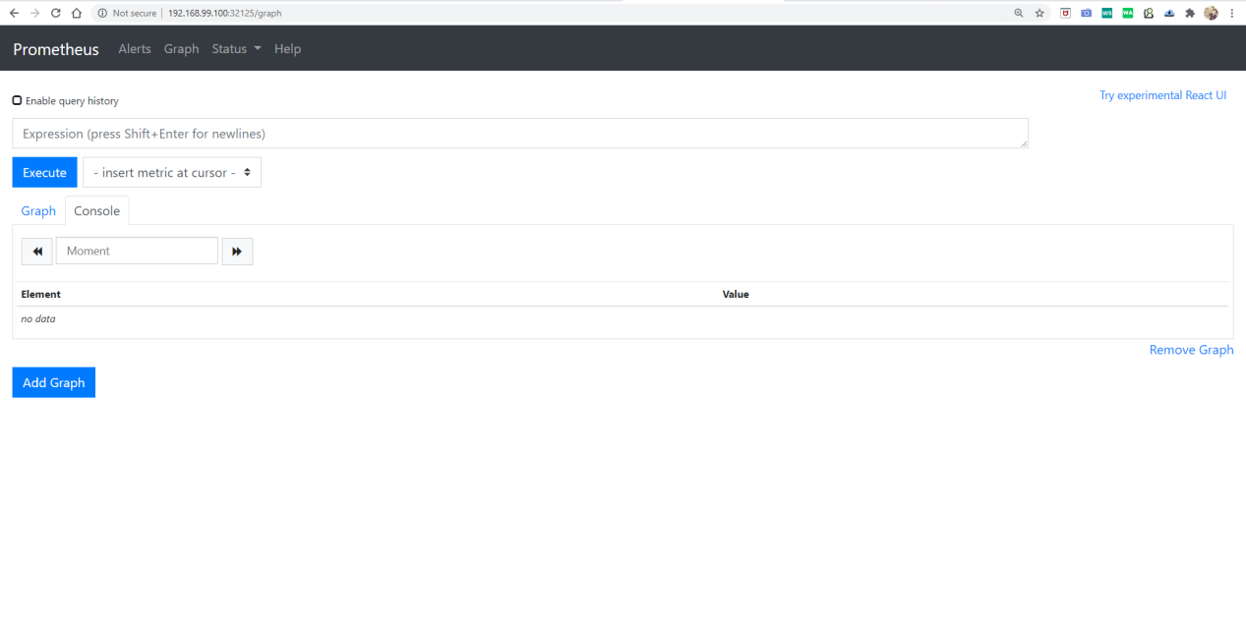

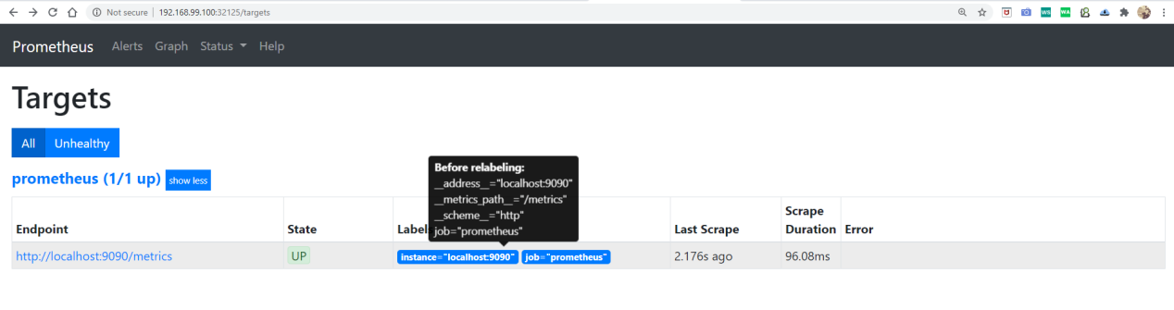

Grafana Dashboard :-



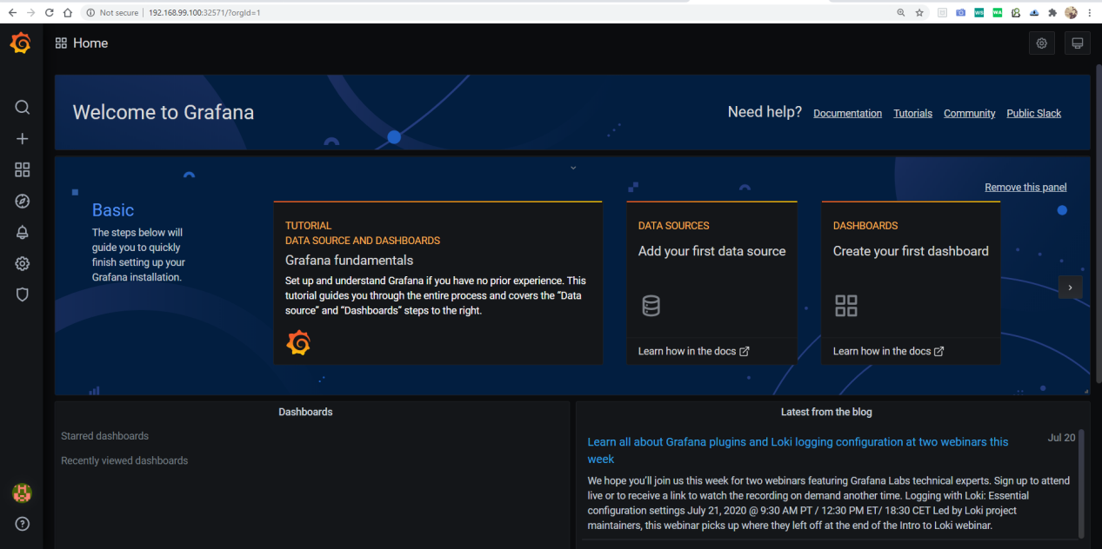

And we can add data sources into it and lots of other things

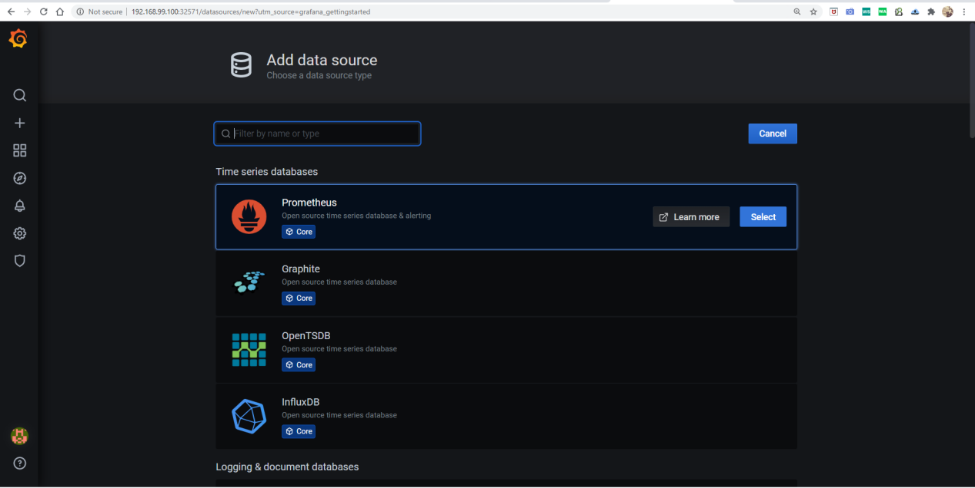

And the same Environment can be Destroyed Using one command I.e. **kubectl delete -k .**

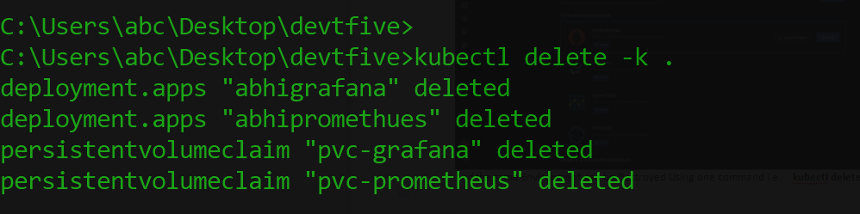



**Thanks you Vimal SIr For Teaching us so much intresting tools and technologies so that today we can create projects By Out Own .**

**Thank you EverOne For Reading !!**